Dear Parent/Carer,
As your child embarks on the Read, Write, Inc. (RWI) program in Reception, they will receive an RWI reading book. In the initial stages, a ‘Sound Blending’ book will be provided, reinforcing the sounds covered in RWI sessions. These sounds are introduced during Phonic sessions, enabling your child to apply their segmenting and blending skills while practicing at home. Progressing through the RWI program, the books will pose increasing challenges.
Upon entering the ‘Red Ditty Group’, your child will bring home a book read in their group. Your child should approach this familiar text with confidence and fluency. These books are meant for independent reading with supervision, offering an opportunity for your child to showcase their abilities. They comprise words your child can phonetically decode and include some tricky red words, displayed in red print for easy recognition. Red words, not phonetically decodable, require memorisation, enhancing your child's reading skills.
Alongside RWI texts, your child will also bring home RWI book bag books, introducing new words that may need decoding. Your support may be required as your child navigates through this text.
A visit to the school library will allow your child to choose a book for shared enjoyment, fostering a love for reading. This book is meant for you to read to your child, modelling expression and excitement.
It's crucial to cultivate a culture where reading is both a valued skill and an enjoyable activity for children. Please prioritise reading with your child and sign their reading diary regularly so staff know when reading books require changing.
Read Write Inc Group Progression
Sound Blending Group A
Sound Blending Group B
Sound Blending Group C
Photocopied Ditties
Red Ditties
Green | Purple
Pink
Orange
Yellow
Blue
Grey
Off the Programme

Below, you will find the Read, Write Inc. group progression colours, a table providing more information about the books your child will bring home, and some helpful tips to support home reading.
Thank you for your continued support.
Priory Reading Team
What books should my child be reading at home?
Core Teaching Book  The story time book that children have been reading in school that current week.  Children to read independently, with ease | 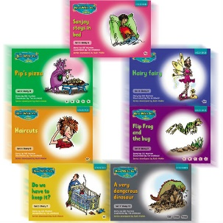 | Once your child is able to read the Read Write Inc Phonics Storybooks, he or she will bring home a Storybook.  Your child will have read this story three times with their reading teacher in school, so should be able to read the story confidently. A brief explanation of how to follow the activities is included in the books.  Children will be able to feel confident about reading and will be able to read this book with fluency and speed. They will have a good understanding of this book and will be able to talk about it to an adult.
Read, Write Inc. Book Bag Book  A Read Write Inc book bag book that closes matches the letter-sound correspondences that they can read in school.  Children to read, support may be required | 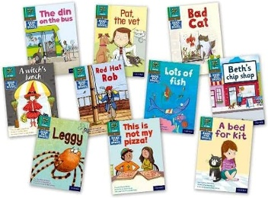 | Your child may also bring home a Book Bag Book.  This book builds upon the ideas and many of the words in the Storybook he or she has just read at school.  Your child will need more support in reading this book as they will not be familiar with the story. However, this book will be matched with the reading ability of the one that he/she is reading within school. Children will be able to access this book at the correct reading level. It is important that children read this book several times. The first read is for children to be able to de-code the words. The second read is for children to be able to develop accuracy and fluency and the third read is for children to be able to develop speed and understanding. The more times the children read the book; the more confident they will become.  Explanation of how to use the activities are included within the books.
Library Book  A book to read for pleasure.  Adults to read to the children | 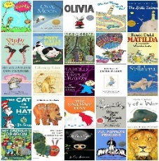 | A ‘free choice’ book to encourage reading for pleasure to ensure that children have access to a broad and balanced reading diet.  This book will include high quality vocabulary for children to be exposed to. It is really important that children have opportunities to listen to high quality texts that are modelled by adults.  This text will create discussion around language, vocabulary and related experiences.


How to support your child with reading at home.
As a school, we would really appreciate if you could support your child at home with their
reading. Children will be provided with 3 books in their book bag on a weekly basis.
Here is how you could support your child with their reading books at home:
• Do not read the book aloud before your child reads it to you.
• Ask your child to read the sounds and words before he or she reads the story.
• When your child reads the story, ask him or her to sound out the words that he or she can’t read automatically.
Encourage the use of the reading process of “special friends….Fred Talk….Read the word”
• Don’t allow your child to struggle too much. Praise your child when he or she succeeds.
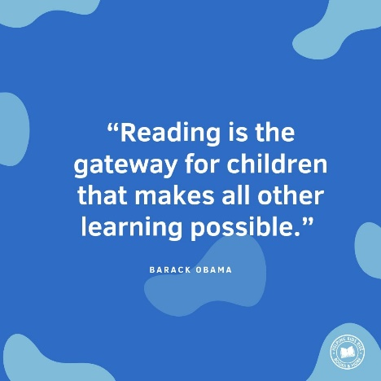
• Read back each sentence or page to keep the plot moving. (Your child’s energy is going into reading the
words not understanding the story.)
• Do not ask your child to guess the word by using the pictures.
• It is recommended to re-read texts several times to develop accuracy and fluency.
• Encourage children to discuss the text and develop their verbal comprehension skills.
• Do it all with patience and love.

