Priory Primary School
Achieving our best; supporting and celebrating each other.

SEND Policy

Approved by: | Governing Body | Date:
Last reviewed on:
Next review due by: | Autumn 2026

Contents:

Section 1: | Compliance and Key Contacts | 3
Section 2: | Aims and Objectives | 3
Section 3: | Defining & Identifying Special Educational Needs | 4-5
Section 4: | The Graduated Approach on SEND Support | 6-7
Section 5: | Referral for an Educational Health Care Plan | 8
Section 6: | Monitoring and Evaluation of SEND | 8
Section 7: | Educational Inclusion | 8
Section 8: | Admission Arrangements | 9
Section 9: | Supporting Pupils and their Families | 9
Section 10: | Supporting Pupils with Medical Conditions | 9
Section 11: | Roles and Responsibilities | 10
Section 12: | Storing and Managing Data | 10
Section 13: | Training and Resources | 11
Section 14: | Dealing with Complaints | 11
Section 15: | Policy Monitoring Arrangements | 11
Section 16: | Appendices | 12-15

Section 1: Compliance
This policy complies with the statutory requirement laid out in the SEND Code of Practice 0 – 25 (January 2015) and has been written with reference to the following guidance and documents:
• Equality Act 2010: advice for schools DfE (Feb 2013)
• SEND Code of Practice 0 – 25 (January 2015)
- The Children and Families Act (March 2014)
• Schools SEN Information Report Regulations (September 2014)
• Statutory Guidance on Supporting pupils at school with medical conditions (December 2015)
• The National Curriculum in England Key Stage 1 and 2 framework document (Sept 2013)
• Safeguarding Policy
• Accessibility Plan
• Teachers Standards (September 2012)

Key Contacts:
SENCo/SLT SEND Advocate: Mrs L Adams
SEND Governor: Mr M Simmonds
To contact the SENCo or SEND Governor, please call the school office on 01245 225450.

Section 2: Aims and Objectives
The aims of this policy are:
• To create a positive, nurturing and inclusive whole school environment that meets the special educational needs of each child through removing barriers to learning as effectively as possible and enabling them to reach optimal levels of achievement;
• To ensure that special educational needs are identified as early as possible and provided in all areas of school life;
• To make clear the expectations of all partners (children, parents, carers, staff and governors) and to encourage participation and engagement in the process;
• To identify the roles and responsibilities of staff in providing for children’s special educational needs;
• To enable all children to have full access to all elements of the school curriculum, where children feel safe to voice their opinions of their own needs.

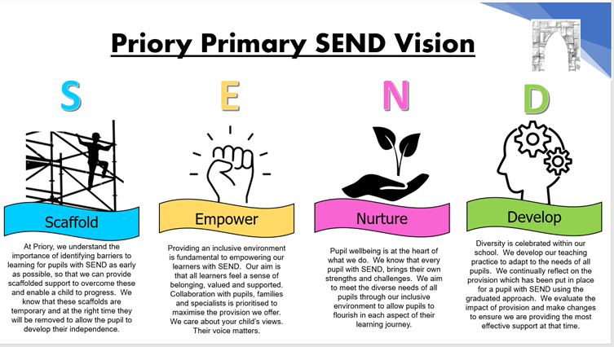

Section 3: Defining and Identifying Special Educational Needs
Definitions of special educational needs (SEN) taken from the Special Educational Needs and Disability Code of Practice: 0 to 25 years (January 2015):
‘A child or young person has SEN if they have a learning difficulty or disability which calls for special educational provision to be made for him or her. A child of compulsory school age or a young person has a learning difficulty or disability if he or she:
• has a significantly greater difficulty in learning than the majority of others of the same age
• has a disability which prevents or hinders him or her from making use of facilities of a kind generally provided for others of the same age in mainstream schools or mainstream post-16 institutions.
For children aged two or more, special education provision is educational or training provision that is additional to or different from that made generally for other children or young people of the same age by mainstream schools, maintained nursery schools, mainstream post-16 institutions or by relevant early years providers. ‘
The Four Broad Areas of Special Educational Needs and Disabilities
There are four broad areas of Special Educational Needs and Disabilities. The areas give an overview of the range of needs that should be planned for.
The purpose of identification is not to fit a child into a category but consider the needs of the whole child which will include not just the special educational needs of the child or young person.
- Communication and Interaction – for example: speech and language difficulties, Autistic spectrum difficulties.
- Cognition and Learning - thinking and understanding e.g. this could be all of the work in school or specific problems with reading and writing or number work.
- Social, Emotional and Mental Health (SEMH) – for example: difficulties with relating to or behaving with other people, depression or anxiety.
- Sensory and/or Physical Needs – for example: impairments of sight or hearing, difficulties with fine or gross motor skills or physical disabilities.

The government has reformed the way in which provision and support is made for children and young people with special educational needs and/or disabilities in England. More details about the reforms and the SEN Code of Practice can be found on the Department for Education’s website:
https://www.gov.uk/topic/schools-colleges-childrens-services/special-educational-needs-disabilities

Identification of SEND
See Appendix 1 for the typical process by which a child is identified as having SEND.
In order to identify children with SEND, the school will:
- Assess children’s skills and attainment on entry and liaise with previous settings
- Regularly assess pupil progress (formally recording pupil progress at regular points through the year for Reading, Writing and Maths using teacher assessments in KS1 and NFER in KS2)
- Pupil Progress Meetings will take place at least twice per year, when each class teacher will meet with members of the Senior Leadership Team (SLT) to discuss pupil progress and identify those pupils whose progress is a concern. They will discuss appropriate measures for the Class Teacher to implement in order to support those pupils.
- Identify pupils making less than expected progress which:
- Is significantly slower than that of their peers starting from the same baseline
- Fails to match or better the child’s previous rate of progress
- Fails to close the attainment gap between the child and their peers
- Widens the attainment gap
It can include progress in other areas than attainment – for instance wider developmental or social need.
- Initial Concerns about a child may also be raised in a number of other ways; these typically include:
- The class teacher observing difficulties in learning, unusual behaviours, or other concerns.
- A parent raising concerns about their child’s progress, development, behaviour or emotional state.
- Regular monitoring of pupil progress flagging up a plateau or drop in progress.
It is important to remember that many causes can impact on pupil progress other than SEND. The school and parents should consider possible causes as part of the decision-making process. Examples of these are:
- Disability (the Code of Practice outlines the “reasonable adjustment” duty for all settings and schools provided under current Disability Equality legislation – these alone do not constitute SEN)
- Attendance and Punctuality
- Health and Welfare
- English as an Additional Language (EAL)
- Being in receipt of Pupil Premium Grant
- Being a Looked After Child
- Being a child of Serviceman/woman
- Traumatic events such as bereavement, divorce or homelessness
It is also important to remember that unusual, disruptive or aggressive behaviour is not a Special Educational Need but can be a response to an underlying need.
Next Steps
As part of gathering information to form an accurate picture of the pupil’s needs, class teachers will complete a SEND Pupil Referral Form (appendix 2) and share concerns with the SENCO. Early discussions will take place with the pupil and parents to develop a good understanding of pupil’s areas of strengths and difficulty. Outcomes and next steps will be planned and agreed.
‘The first response to such progress should be high quality teaching targeted at their areas of weakness. Where progress continues to be less than expected the class or subject teacher, working with the SENCO, should assess whether the child has SEN. While informally gathering evidence (including the views of the pupil and their parents) schools should not delay in putting in place extra teaching or other rigorous interventions designed to secure better progress, where required. The pupil’s response to such support can help identify their particular needs. ‘(SEND Code of Practice, 2015)

Decision to Place a Child on the SEND Register
When deciding if a child should be recorded on the SEND register, class teachers along with the SENCO will determine the support that is needed and whether it can be provided through the core provision which is ‘Ordinarily Available’ to all pupils.
The decision will be made with the involvement of parents and any other specialists, agencies or staff involved. If the child requires support which is additional to or different to this core provision the child will be placed on the SEND Register and will begin the One Planning (Graduated Approach Cycle.)

Section 4: A Graduated Approach to SEN Support
One Planning is a way to support children and young people to make progress towards the things that matter to them. You might also hear this cycle being referred to as the 'graduated' approach or person-centred planning - these are the same thing.
One Planning is a term generally used by Essex education settings and follows the graduated approach of assess, plan, do & review, as outlined in the SEND Code of Practice 2015.

The SEND Code of Practice (2015) says:
‘Where a pupil is identified as having SEN, schools should take action to remove barriers to learning and put effective special educational provision in place. This SEN support should take the form of a four-part cycle through which earlier decisions and actions are revisited, refined and revised with a growing understanding of the pupil’s needs and of what supports the pupil in making good progress and securing good outcomes. This is known as the graduated approach. (6.44)’

When your child is identified has having SEND, the school will use a graduated approach based on four steps.
- Assess
- Plan
- Do
- Review
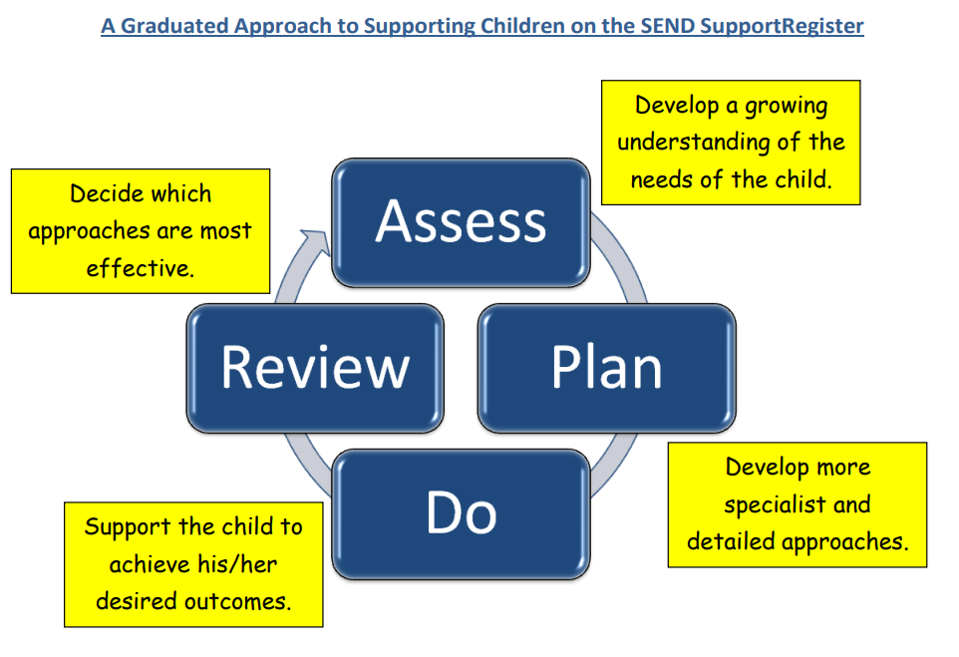

Assess
Class teachers will work with the SENCO to assess pupil’s needs, so that they receive the right support.

Plan
If the school decides that a pupil needs SEND support, parents will be informed. The school will meet with parents termly to agree the outcomes and share information about the help that will be provided. Targets will be set and a date confirmed for progress to be reviewed.

Do
The class teacher is responsible for the One Plan and will work closely with any teaching assistants or specialist staff involved.

Review
The school will review pupil’s progress against set outcomes termly with parents. The purpose of the meeting is to review what has worked well and further action required.

If the pupil has not responded to the help they were given, the review should decide what can be done next. This may include more or different help. Sometimes the next step may be to ask the local authority for an EHC needs assessment. The school will discuss this with parents and if they think it is needed they can request it.
Removal from the SEN Register
When a pupil no longer needs additional provision and their needs can be met by the school’s Ordinarily Available Provision (core provision), they will be removed from the SEND Register. The decision will be made by the SENCO in consultation with the pupil, parents and class teacher.

Section 5: Referral for an Education, Health and Care Plan (EHCP)
The SEND Code of Practice (2015) states that if a child has lifelong or significant difficulties, they may undergo a Statutory Assessment Process which is usually requested by the school but can be requested by a parent. This will occur where the complexity of need or a lack of clarity around the needs of the child are such that a multiagency approach to assessing that need, to planning provision and identifying resources, is required.
The decision to make a referral for an Education, Health and Care Plan (EHCP) will be taken at a progress review. The application for an Education, Health and Care Plan will combine information from a variety of sources including:
- Parents
- Teachers
- SENCO
- Social Care
- Health professionals

Information will be gathered relating to the current provision provided, action points that have been taken, and the preliminary outcomes of targets set. A decision will be made by a group of professionals from education, health and social care about whether or not the child is eligible for an EHCP. Parents / carers have the right to appeal against a decision not to initiate a statutory assessment leading to an EHCP. Further information about EHCP can found via the SEND Local Offer.
Section 6: Monitoring and Evaluation
The SENCO monitors the movement of children within the SEND system in school. The SENCO provides staff and governors with regular summaries regarding SEND provision.
The SENCO is involved in supporting teachers in target setting and providing strategies or resources for children requiring additional provision. The SENCO and the Head Teacher hold regular meetings to review the work of the school in this area.
The school regularly monitors and evaluates the provision we offer to all pupils through:
- Teacher observations
- Pupil progress meetings
- Learning walks
- Meetings between the SENCO and SEND governor
- Pupil Voice
SEND provision and interventions are reviewed by the SENCO. SEND provision can be monitored through the use of provision maps.
The Governing Body reviews this policy annually and considers any amendments in the light of the annual review findings. The SENCO reports the outcome of the review to the full governing body.
Section 7: Educational Inclusion
We want all children to feel that they are valued in our school community. We aim to achieve this through the removal of barriers to learning and inclusive participation. We have high expectations of all children and through appropriate curricular provision, we respect the fact that children:
- have different educational and behavioural needs and aspirations;
- require different strategies for learning;
- acquire, assimilate and communicate information at different rates;
- need a range of different teaching approaches and experiences.
We respond to children’s needs by:
- having high expectations for every pupil,
- providing support for children who need help with communication, language, literacy and numeracy; planning to develop children’s understanding through the use of all available senses and experiences;
- planning for children’s full participation in learning, and in physical and practical activities;
- using positive strategies to help children to manage their behaviour and to take part in learning effectively and safely;
- helping individuals to manage their emotions, particularly trauma or stress, and enabling them to engage in learning experiences.
The SENCO oversees inclusion and is responsible for ensuring that it is implemented effectively throughout the school. The school curriculum is regularly reviewed to ensure that it promotes the inclusion of all children.
The school will seek advice, as appropriate, around individual children from external support services.
Section 8: Admission Arrangements
All children with SEND have the right to be educated in a mainstream school. Admission
arrangements for children with special needs in line with our admissions policy are considered.
Section 9: Supporting Pupils and their Families
The SEND Local Offer is a resource which is designed to support children and young people with special educational needs and/or disabilities and their families. You can find a link to this on the school website. The Local Offer describes the services and provision that are available both to those families in Mid Essex that have an Education, Health and Care Plan and those who do not have a plan, but still experience some form of special educational need. The SEND Local Offer includes information about public services across education, health and social care, as well as those provided by the private, voluntary and community sectors.
The Local offer can be accessed via https://send.essex.gov.uk/
Exams and Assessments
At Priory Primary, we employ Teacher Assessment processes, through class teacher observation and ongoing informal assessment. Where tests are carried out, each child is accommodated according to his/her needs. Some children will be exempt from all tests and are assessed in other ways; some are supported to complete tests by an adult or by completing a test over a number of days; some children are given additional time or movement breaks in order to allow them to complete a test.
Additional time or support can be sought for SEND Year 6 pupils completing their SATS through a prescribed application process.
Transitions
Children with identified SEND who will be joining Priory Primary in Reception class will be visited by the class teacher or SENCO in their preschool setting. The school will discuss their needs with their parents/carers. A transition programme will be agreed between the school and the parents to best support the child on entry to the school.
When children leave Priory Primary to begin secondary school, their SEND files will be sent to their new school. Most secondary schools liaise with primary schools to gather information about their new pupils and the Year 6 teachers will complete any requests for information received, with support from the SENCO where necessary.

Section 10: Supporting Pupils at School with Medical Conditions
The school recognises that pupils at school with medical conditions should be properly supported so that they have full access to education, including school trips and physical education.
Some children with medical conditions may be disabled and where this is the case the school will comply with its duties under the Equality Act 2010.
Some may also have special educational needs (SEN) and may have an Education, Health and Care Plan (EHCP).

Section 11: Roles and Responsibilities
SEND Governor
The Governing body of maintained mainstream schools must ensure that there is a qualified teacher designated as SENCO for the school. The governors and headteacher should ensure that the SENCO has sufficient time and resources to carry out the functions detailed below. This should include providing the SENCO with sufficient administrative support and time away from teaching to enable them to fulfil their responsibilities in a similar way to other important strategic roles within a school.
The SEND Governor is responsible for:
- Making sure that the school has an up to date SEND Policy
- Making sure that the school has appropriate provision and has made necessary adaptations to meet the needs of all children in the school
- Making sure that the necessary support is made for any child who attends the school who has SEN and/or disabilities.
- Making visits to understand and monitor the support given to children with SEND in the school and being part of the process to ensure your child achieves his/her potential in school.
SENCO
At Priory Primary School the Special Educational Needs Co-ordinator (SENCO):
- Manages the day-to-day operation of the policy;
- Co-ordinates the provision for and manages the responses to children’s special needs;
- Supports and advises colleagues;
- Maintains the school’s SEND register and Provision Map;
- Contributes to and manages the records of all children with special educational needs;
- Reviews school-based assessment and completes the documentation required by outside agencies and the LA;
- Acts as a link with parents;
- Maintains resources and a range of teaching materials to enable appropriate provision to be made;
- Acts as a link with external agencies and other support agencies;
- Monitors and evaluates the special educational needs provision and reports to the governing body;
- Manages a range of resources, human and material, linked to children with special educational needs.
- Contributes to or arranges the training of class LSAs and contributes towards the performance management of LSAs.
Section 12: Storing and Managing information
Documents relating to pupils’ SEND are stored in files in a locked filing cabinet in the SENCO’s office. Electronic documents are stored in a folder on the school server that is only accessible to the SENCO.
Transfer of electronic files will be protected in line with Local Authority guidelines. Copies of documents that are relevant to the teaching of pupils can be requested by class teachers and LSAs from the SENCO, and copies of these documents will be given to the class teacher or LSAs in order to inform their planning and support for the pupil. These may include documents such as Speech and Language therapist reports, Educational Psychologist reports, Medical diagnoses or recommendations, etc. These documents are stored in files in the classroom out of sight or out of reach of children while not actively in use.
When a child leaves the school, their SEND file will be passed on to their new school either electronically or in paper form.

Section 13: Staff Training
At Priory School, we recognise that all staff who work with children are responsible for children with SEND.
We aim to keep all staff up to date with relevant training and developments in teaching practice in relation to the needs of children with SEN through internal communication, staff meetings and briefings.
The SENCO attends local authority SENCO cluster meetings in order to keep up to date with local and national SEND developments and to share best practice.
As training needs for staff are identified, the senior leadership team will organise specific training or invite experts to deliver training on a specific area of need.
Section 14: Dealing with Complaints
If you feel that you need to make a complaint at any time, please initially contact your child’s class teacher or the SENCo Mrs Adams. In most cases, we find that concerns can be dealt with successfully at this level. However, if this is not possible, the concern may be escalated and raised as a complaint with headteacher, please see the school complaints procedure in the policies section of the website.
The parents and carers of pupils with disabilities have the right to make disability discrimination claims to the first-tier SEND tribunal, if they believe that our school has discriminated against their child.
They can make a claim about alleged discrimination regarding:
- Suspensions
- Provision of education and associated services
- Making reasonable adjustments, including the provision of auxiliary aids and services

Section 15: Policy Monitoring Arrangements
This policy will be reviewed by Mrs L Adams, SENCo, annually. At every review, the policy will be approved by the governing body and Ms. Laver, headteacher.

Appendix 1: SEND Identification Flow Chart
Concerns raised by member of staff
Concerns raised by progress /data
Concerns raised by class teacher
Concerns raised by parents
Child’s needs can be met through agreed targets using HQT strategies
Monitoring and assessment continues as normal

SEND Referral Form to be completed by class teacher and shared with SENCO
Initial discussion with class teacher

Meeting with Class teacher, SENCO, families & the child to consider outcomes and provision required.
Concerns continue
Concerns resolved
Targets agreed. Monitor in class and implement HQT strategies

Monitoring and assessment continues as normal
External agency support & assessment sought if required
SENCO decides if needs can be met through HQT

Provision is required which is additional to or different to that of the child’s peer
Child is recorded on the SEND register

One Page Profile is created with the child

One Plan is produced by the teacher. Graduated approach begins.

Appendix 2: SEND Identification Referral Form

Name of Pupil: |  | Date:
Class/Year Group: |  | Class Teacher(s):
Attendance to date: |  | Referrer:

Tick all concerns that apply:
Medical |  | Academic |  | Other – please specify
Communication |  | SEMH
Social |  | Physical/Sensory

Pupil’s Strengths:

Assess:
Concerns -When did you first have concerns, any initial assessments done?
What are the pupil’s needs/barriers to learning?

Communication and interaction

Cognition and learning

Social, Emotional and Mental Health

Physical and Sensory

Relevant Assessment Information and Current Attainment:
(Working towards expected standard WTS/ Working at expected standard EXE/ Working at greater depth GDS)
Reading
Writing
Mathematics

Other:

Other adults/agencies involved:

Parents/Guardians
Advised:
By who? Face to face / telephone / meeting?
Parents/Guardians
Initial comments:

Do: High-quality teaching strategies used?  How have you adapted teaching to meet the pupil’s needs above and beyond the ordinarily available in your classroom?  e.g. Now/next/then, brain break, visual timetable, safe space etc. |  | Review: What was the impact of these adaptions?
Action Taken | Date | Outcome/Impact | Date

For SENCO use only:

Plan: Further actions (to be completed by the SENCO and Class Teacher).
Do we need to make any referrals? What outcomes do we want to achieve?

Impact/Actions and Date

Do |  | Review
Action Taken | Date | Outcome/Impact | Date

