Priory Primary School
Achieving our best; supporting and celebrating each other.

SEND* Information Report
2026 – 2027

*Special Educational Needs

Schools have a duty to report annually to all parents on the provision for SEND. This SEND Information report is our annual report for the academic year 2026-2027.

Contents:
What is SEND? | 3
What types of educational needs do we ensure effective provision for? | 3
Our School Vision | 4
Key Staff | 4
How do we identify and assess children with SEND? | 5
What should I do if I think my child needs extra help? | 5
How do we consult with children and families? | 6
Our approach to teaching children with SEND | 5
Curriculum Adaptations | 6
Outside Agencies | 7
Staff Training | 7
Clubs and Trips | 8
Transitions | 8
Useful Information | 8
Complaints | 9
Appendix 1 | 10

What is SEND?

A child has SEND if they have a learning difficulty or disability that we need to make special provision for. Some key terms explained:
- learning difficulty: when a child finds it harder to learn than most children do.
- disability (that we need to make special provision for): something that hinders a child from using our school facilities.
- special provision: support that is extra or different to what is typically provided.

What types of special educational needs do we ensure effective provision for?
At Priory Primary School we support children with a variety of differing special educational needs and we pride ourselves on being a highly inclusive school with an ethos which encourages and celebrates diversity and difference.
SEND is categorised into the following areas in the SEN Code of Practice 2015:
 | Cognition and Learning
 | Communication and Interaction
 | Social, Emotional and Mental Health
 | Sensory and Physical

Some children may have more than one type of SEND. We welcome children with all the above types of SEND who have applied for a place.

All children with SEND have the right to be educated in a mainstream school. Admission
arrangements for children with special needs in line with our admissions policy are considered.

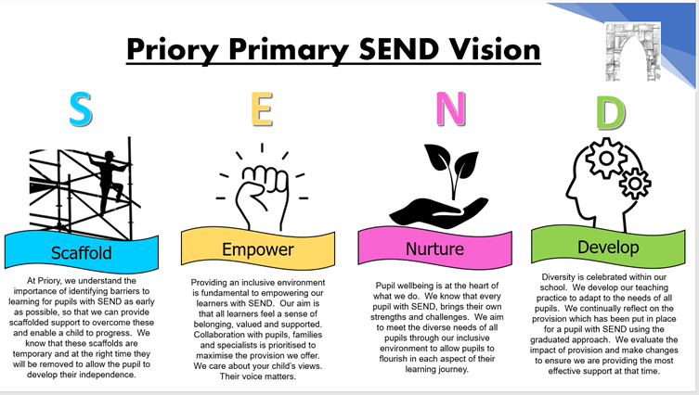


Meet our key staff to support children with SEND

SENCO – Mrs L. Adams
Class Teachers – All staff have a duty of care to support children with SEND.
Assistant Headteacher – Mr B Cole
Headteacher – Ms. C Laver
SEND Governor – Mr M Simmonds

How do we identify and assess children with SEND?
At Priory Primary School we work closely as a team and if staff have a concern about a child, they fill in the SEND Pupil Referral Form which is discussed with the SENCO. Teachers will communicate concerns with parents during this whole process to ensure that we work together to provide the best provision for each child.
The first response to concerns will be high quality teaching to target areas of weakness utilising the Ordinarily Available Inclusive Teaching Framework. A child’s progress will be closely monitored using the Graduated Response approach of ‘Assess, Plan, Do and Review’.
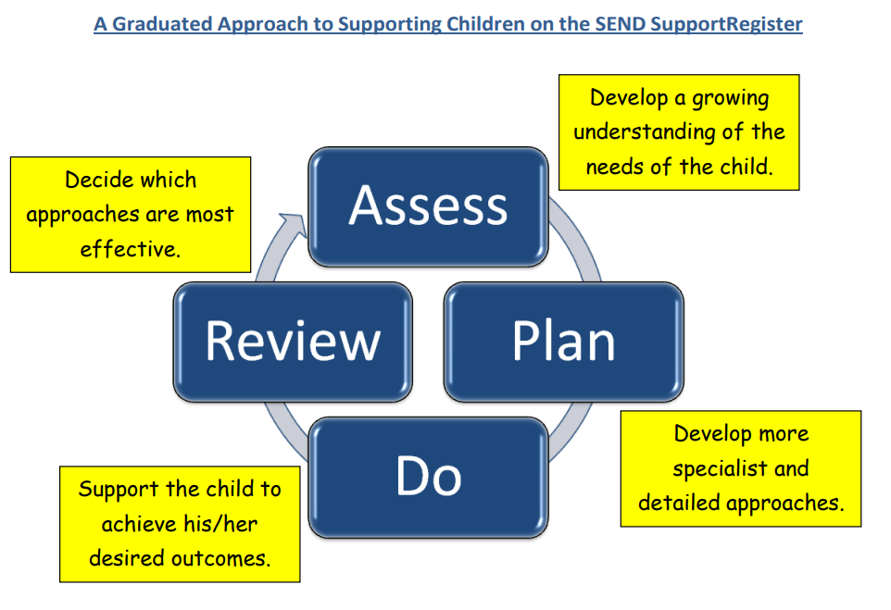

After an agreed period of time, we will decide if a child needs to be placed on the SEND register. You will be invited to a One Planning meeting, where we will share the targets your child is working on and the support they are receiving.

What should I do if I think my child needs extra help?
Speak to your child’s class teacher if you have any concerns regarding their progress, learning or well-being.
Class teachers will then follow the school process for identifying children with SEND.
See Appendix 1 on page 9.

How do we consult with children with SEND?
The views of the child are important to us; they have a right to be involved in decisions about their education and they are made aware of the support that surrounds them in school.

Children can discuss their concerns with any member of staff who they feel comfortable speaking with. Following this, staff follow the procedures for identification of children who may require additional support.

Children have the opportunity to share their views as part of the One Planning process. At the start of each year, children will work alongside a member of staff to create a One Page Profile using https://sheffkids.co.uk/resources/

This provides an opportunity for the child to reflect and review their current support and needs.

Children are given regular opportunities to:

 |  | 
Self-assess how they are doing. | Attend meetings and help decide the support needed. | Feedback and Review progress/interventions.

How do we consult with families of children with SEND and involve parents in the education of their child?

At Priory Primary School we work closely with parents and carers. We recognise that they have much to contribute to our support for children with SEND and the progress children make.
In addition to the parent’s consultation meetings available to all families, children who have One Plans or require specialist support (over and above what is ordinarily available) will be invited in for 3 further meetings a year in the Autumn, Spring and Summer term. These meetings are used to celebrate your child’s learning, look at the progress they have made against the targets set, create new targets and discuss next steps. A copy of this will always be sent home after the meetings.
As part of the One Planning process at Priory Primary School, a parental questionnaire is sent out to gain views on the SEND provision your child is receiving. This supports the school to evaluate SEND provision.
For children who have an Education Health Care Plan, as well as One Planning meetings families will be invited to review provision during an annual review with our school SENCO.
Class teachers are easily contactable via the telephone, school office or email should parents wish to discuss any concerns regarding their child and their learning.
Our approach to teaching children with SEND
We are an inclusive school. Wherever possible children are taught alongside their peers in flexible teaching groups.
We use the Ordinarily Available Guidance produced by the Local Authority to complement our teaching (April 2023).
Teachers adapt their high-quality teaching to cater for a child’s needs and to plan individual timetables where necessary. When appropriate, staff are deployed to give children additional interventions in small groups outside the classroom, or to provide one-to-one support
We can provide the following interventions:
- Zones of Regulation
- Precision Teaching
- Pre-teach and Post-teach opportunities
- Lego Therapy
- RWI Tutoring
- Write from the Start
- IDL (International Dyslexia Learning)
- SNIP Spelling Programme
- Power of 2

Interventions will be implemented based on children’s’ individual needs. Please note this list is not exhaustive.
Curriculum Adaptations
We use a range of strategies across our lessons to ensure we offer an inclusive approach to learning and allow all children to access the classroom environment.
We also seek advice and equipment from outside agencies as and when the need arises.

How do we evaluate the effectiveness of provision for children with SEND?
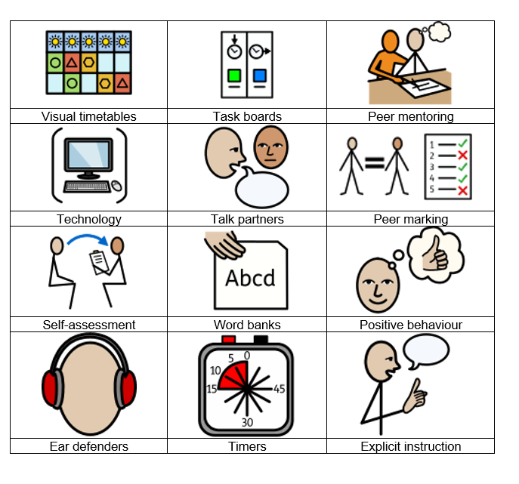
Priory Primary School regularly monitors and evaluates the provision we offer to all children through:
- Teacher observations
- Pupil progress meetings
- Learning walks
- Meetings between the SENCO and SEND governor
- Pupil Voice
- Intervention Trackers

Outside Agencies


If your child needs specialist support from an outside agency, such as the Speech and Language Service (SALT), Educational Psychologist (EP), Occupational Therapist (OT) or school nurse, we will always discuss this with you first.

We work with the following agencies and services to provide support for children with SEND:

- Speech and Language Therapy

- Educational Psychologists
- Occupational Health
- The Affintiy Project
- Early Help Mid Essex
- Essex Child and Family Wellbeing Service
- GROW provision
- Physical Neurological Impairment Specialist Teacher

Staff Training


At Priory Primary School, we believe in professional development and aim to ensure all our staff have the skills, knowledge, and understanding they need to enable them to support your child.
When a new member of staff joins the school, we ensure they understand the systems within school and they are given information about the children they are working with.
The senior leadership team are constantly moderating needs within the school and, where an area of concern is highlighted, whole school training can be organised to ensure all staff understand specific learning difficulties and appropriate teaching or support strategies that could be used.
Clubs and Trips


All our extra-curricular activities and school visits are available to all our children. All children are encouraged to go on our trips and to take part in sports day, school competitions, school assemblies and performances etc.

All children are encouraged to apply for roles of responsibility in school e.g. school council.

No child is ever excluded from taking part in these activities because of their SEN or disability. We make reasonable adjustments so that children who have SEND can join in with every aspect of school life.

Staff may need to talk to parents to plan adjustments or a parent can talk to their class teacher or our SENCO about what adjustments might need to be made.

How do we support children moving between different school settings?

(Children moving from Nursery to Primary School or Primary School to Secondary School)


For our new reception starters, Priory Primary School plan opportunities for children to meet with their class teacher and to spend time in the new environment.

When children move up a year, class teachers will meet during the summer term to discuss the needs of the children and share One Plans.
We hold a ‘Meet the Teacher’ session for children during the summer term allowing the children to go to their new classroom and meet their teacher. Some children may require extra transition visits to their new classroom to help reduce their anxiety. Teachers will provide social stories or photographs of the new environment to support this transition period if needed.
We liaise very closely with our partner schools to ensure that the transition from primary school to the secondary school is as smooth as possible.
When we are aware that a child is joining us from a different setting, who has an identified special educational need, we will arrange a meeting with the family to enable us to gain a greater understanding of the support we need to put in place.

Useful Information

The Local Offer:
https://send.essex.gov.uk/

The Local Offer is a website that is written for parents and families. It helps them know ‘what is out there’ for youngsters with SEND in our local area. It includes:
- support services
- health services (e.g. contacts for the NHS speech and language team)
- leisure activities (e.g. SEN sports clubs)
- contacts for SEN charities

Essex SENDIASS:
https://www.essexsendiass.co.uk/

SENDIASS is an independent advice and support service which provides free, confidential and impartial information, advice and support about SEND for children, young people, parents and carers.

Your first point of contact is your child’s teacher. However, If you have any further questions regarding the provision for your child with SEND, please do not hesitate to contact the SENCO. You can either:
- Contact the school via telephone 01245 225 450
- E-mail queries or concerns to admin@priory.essex.sch.uk
- Arrange a meeting with a member of staff including the senior leadership team.
- Arrange a meeting or speak to the Headteacher

For more detailed information about SEND at Priory Primary School, you can find our school SEND Policy on our website:
https://www.priory.essex.sch.uk/page/?title=SEND&pid=29

Complaints
If you feel that you need to make a complaint at any time, please initially contact the class teacher or the SENCO Mrs Adams. In most cases, we find that concerns can be dealt with successfully at this level. However, if this is not possible, the concern may be escalated and raised as a complaint with headteacher, please see the school complaints procedure in the policies section of the website.
The parents and carers of pupils with disabilities have the right to make disability discrimination claims to the first-tier SEND tribunal, if they believe that our school has discriminated against their child.
They can make a claim about alleged discrimination regarding:
- Suspensions
- Provision of education and associated services
- Making reasonable adjustments, including the provision of auxiliary aids and services

Appendix 1: SEND Identification Flow Chart
Concerns raised by member of staff
Concerns raised by progress /data
Concerns raised by class teacher
Concerns raised by parents
Child’s needs can be met through agreed targets using HQT strategies
Monitoring and assessment continues as normal

SEND Referral Form to be completed by class teacher and shared with SENCO
Initial discussion with class teacher

Meeting with Class teacher, SENCO, families & the child to consider outcomes and provision required.
Concerns continue
Concerns resolved
Targets agreed. Monitor in class and implement HQT strategies

Monitoring and assessment continues as normal
External agency support & assessment sought if required
SENCO decides if needs can be met through HQT

Provision is required which is additional to or different to that of the child’s peer
Child is recorded on the SEND register

One Page Profile is created with the child

One Plan is produced by the teacher. Graduated approach begins.

