Britto  Here We Are! | Science  In Science, children will learn about Animals Including Humans. They will explore the basic needs of humans and animals, identify body parts, learn about the senses and discover how living things grow and change. Practical investigations and observations will help children develop their scientific enquiry skills.  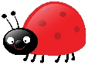
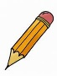
Focus Texts:
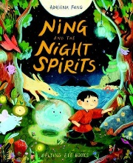
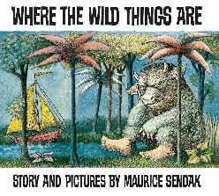
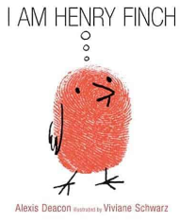
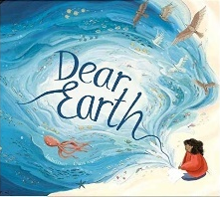

English  Our learning in English will be inspired by a range of high-quality texts including Dear Earth, I Am Henry Finch, Where the Wild Things Are and Ning Ning and the Night Spirits.  Children will develop their reading, writing, speaking and listening skills through storytelling, discussion, drama and creative writing activities. They will explore characters, settings and themes whilst building confidence in expressing their ideas.  Reception will explore different nursery rhymes and begin practising their letter formation.  In Phonics, Reception will learn single sounds and begin to blend sounds to read words. Year 1 will continue learning phonics in groups and will read an increasing amount of words using their sounds. | 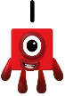  Maths  In maths, Year 1 will focus on developing their understanding of number, calculation and shape. The children will build confidence with numbers to 10 by counting forwards and backwards, finding one more and one less, comparing and ordering numbers, and using number lines. They will also develop early addition and subtraction skills through part-whole models, number bonds to 10, fact families, and solving simple addition and subtraction problems. In geometry, pupils will learn to recognise, name and sort common 2-D and 3-D shapes, as well as identify and create simple shape patterns.  Reception will explore number through songs, games and practical activities. They will develop their counting and subitising skills as well as exploring maths opportunities in the world around them.
  Music  Children will begin the term by exploring Musical Moods and Pictures, learning how music can create feelings, tell stories and inspire images. Later in the term, they will develop their singing, performance and teamwork skills as they prepare for the Christmas Show. |   Computing  Children will explore different aspects of technology through the Teach Computing curriculum. They will learn about technology around us, including how computers and digital devices are used in everyday life. They will also develop creative computing skills through digital photography, learning how to take, edit and evaluate photographs.
History  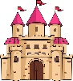  During the first half term, children will learn about Kings, Queens and Castles, exploring life in the past and discovering the roles of monarchs throughout history. In the second half term, they will undertake a Local History Study focusing on War and Remembrance, helping them understand significant events and how these are remembered within the local community. | PE    In PE, children will develop their coordination and movement skills through Ball Skills and Dance activities. During the second half term, they will build teamwork and game-playing skills through Handball and Hockey.
Design Technology & Art  In Art, children will explore Sculpture, experimenting with different materials and techniques to create three-dimensional artwork. During the second half term, Design Technology will focus on Food, where children will learn about healthy eating, food preparation and designing and making simple food products. | PSHE  The children will develop important personal and social skills. During the autumn term they will learn about relationships, including friendship and teamwork, and later focus on health and wellbeing, exploring positive thinking, emotions and strategies for looking after themselves.
RE

In RE, children will explore key Christian beliefs and traditions. They will consider why the word God is important to Christians and later learn about why Christians perform Nativity plays at Christmas, helping them understand the significance of important religious stories and celebrations.

